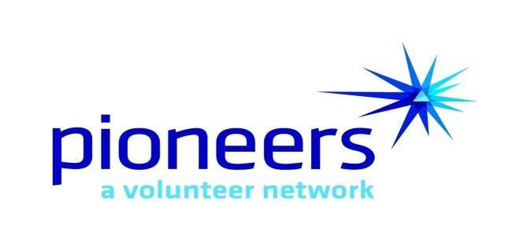

2026 Authorized Voucher Approvers
Date: __________________
Unit (Club/Council) Name: ________________________
Chapter Name & Number: ________________________
Group - AT&T
Milage: _______ Per Mile: _________
Minimum-current IRS charity rate (2025 was 14¢/mile)
Maximum=current IRS business rate (2025 was 70¢/mile)
The IRS typically updates these rates in December each year. Anything above $.14 counts as income
to the Pioneer and if income totals $600 or more for a calendar year, a 1099 will be sent out.
Email Address: ___________________________
President (print name): ___________________________
Email Address: ___________________________
Vice President (print name): ___________________________
Email Address: ___________________________
Immediate Past President (print name): __________________
Email Address: ___________________________
Treasurer (Print Name): ___________________________
Email Address: ___________________________
Other Print Name): ___________________________

Unit Presidents/Treasurers/other officers: Please complete and forward to:
•your Chapter Treasurer _____________________________
•your Unit Treasurer _____________________________
•ritamcoen@gmail.com _____________________________
Date of meeting approving authorized signers: _______________

